Statistics Lecture 3.3: Finding the Standard Deviation of a Data Set

Variation
* How the data is spread apart.

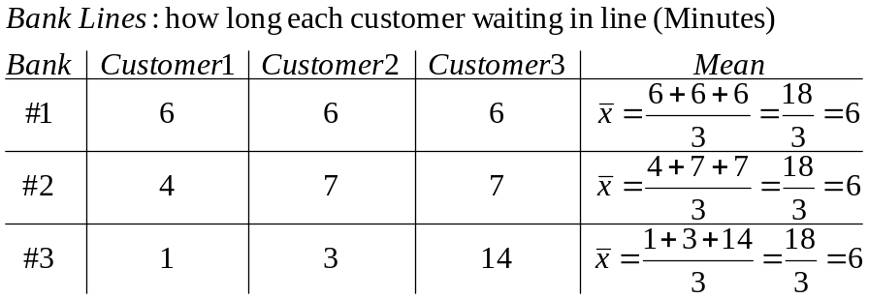

Ways to measure Variaions
- Range: highest value - lowest value (max-min)
Easy to find,
Does not consider all values
- Standard Deviation.
Measures the average distance your data values are from the mean.

Properties.
Never negative.
Never zero unless all data values are the same.
Greatly affected by outliers.

Sample standard deviation is denoted by: s
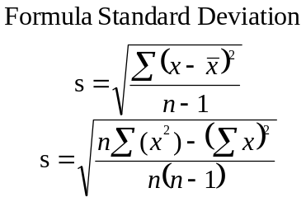

\Find Standard Deviation of 1,3,14
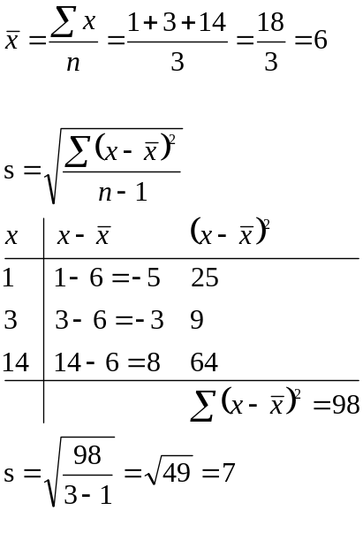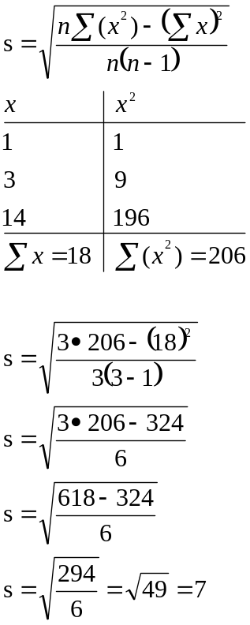

Find Standard Deviation of 4,7,7
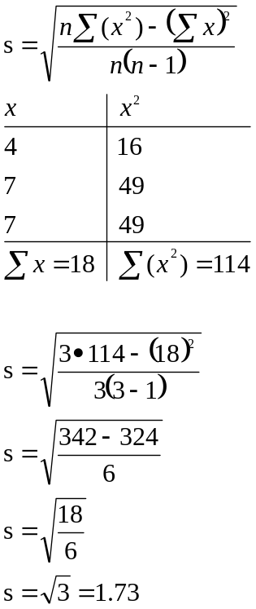

Standard Deviation for a population:
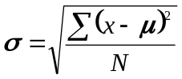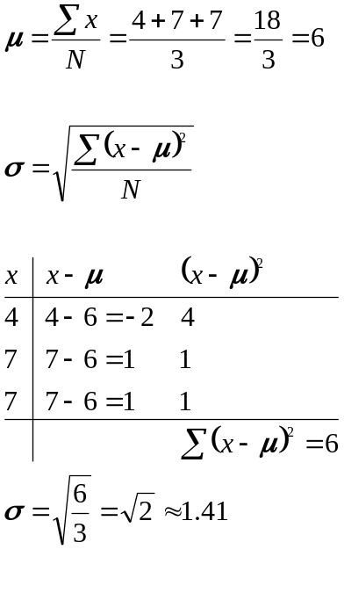

Variance:
Standard Deviation formula less the square root

Sample Variance:
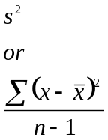

Population Variance
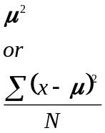

Properties of Standard Deviation
Closely grouped data will have a small standard deviation.
Spread out data will have a large standard deviation

If a data set is normally distributed, we can use the empirical rule:

Empirical Rule:
- 68% of the data will fall within 1 standard deviation of the mean.
- 95% of the data will fall within 2 standard deviations of the mean.
- 99.7% of the data will fall within 3 standard deviations of the mean.

If a Data value falls within 2 standard deviations rom the mean
is considered usual.

A data value outside of 3 standard deviations from the mean is very rare.

Sample:
Heights are normally distributed with a mean of 65 inches with a standard deviation of 3 inches.
Variance is 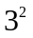
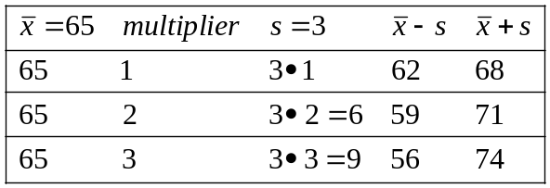

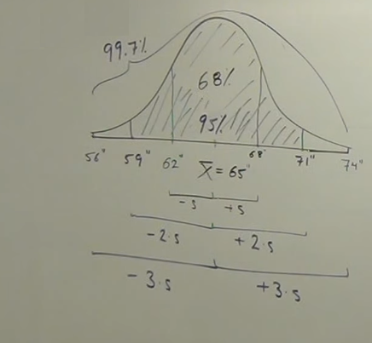
Mean is 34 pounds, standard deviation is 8 pounds.

What percentage of the data will fall between 10 pounds and 58 pounds?

58-34=24, 34-10=24, centered around mean.
24/8=3

number of standard deviations away from mean where s is the standard deviation
is the the upper and lower limit and is the mean.
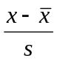

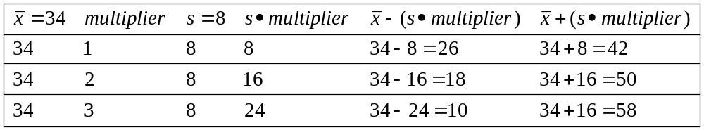

Co-efficient of variation:
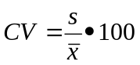
Quick way to determine variation in data
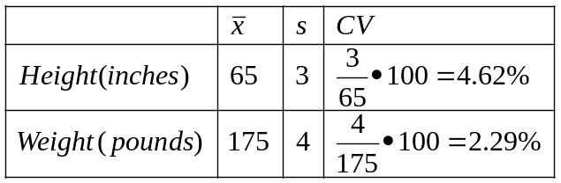
Bigger percentage in the Co-efficient of variation shows a larger spread in data.

